Outline for shelfbreak trend paper

**Introduction**

Justification

Describe region

Warming Trends seen in MAB/Gulf of Maine – much derived from SST (Mills et al 2013, Pershind et. al. 2015) or else ship of opportunity (Forsyth et. al. 2015).

Most lack salinity measurements.

No clear seasonal salinity signature.

Without salinity we can’t know density changes/gradient changes

So, we use 11 years of CTD data from WHOI/MIT JP and SEA cruises.

Brief overview of cruises.

Goals

Describe mean structures and year to year variability in data in T, S and rho.

Describe trends in properties over 11 years.

Describe implications for stratification and frontal gradient.

Compare results with others.

**Methods**

Describe cruises, season

Station locations [Fig 1, map], transect names, and data collected

Data processing, binning, gridding.

Bathymetry from underway CHIRP echosounder

Trends calculated only when there are at least 9 data points at any location.

**Results**

Describe section mean structures [Fig 2, means (and stds?)]:

* Stratified surface warm layer.
* Cold pool on shelf.
* Warm, salty slop water.
* Subsurface shelf break front supporting jet.
* Can see these features in the TS diagrams form the sections [Fig 3, TS, 2004 and 2013 highlighted]
* Occasional Gulf Stream incursions.

Describe variability

* Lots of variability in magnitude of stratification.
* std for T and S highest along sb front indicative of variability in that frontal feature. Shown in example sections [Fig 4, two examples, 2004 and 2013]
* Can see meandering and wave formation breaking at front. Some cases have multiple switchbacks.

Discuss Trends [Fig 5, map of significant trends]:

* Significant trends in surface which sees an increase in temperature of 0.5 degC/yr and density reduction of 0.2 kg/m3/yr
* Trend in slope water also – increase in temp of 0.2 degC/yr and sal of 0.05 /yr. Only modest density loss as a result. Only just significant at 95% confidence.
* No obvious trend in the cold pool. This is deceptive as the cold pool is mobile between years (and sometimes found offshore of the shelfbreak [Fig 4, example sections]

Use TS properties to find trends in cold pool [Fig 6: cold pool trends]

* Temperature increasing (0.2 degC/yr), salinity increasing (0.05 /yr), density remaining constant. Very similar to slope water trends.

[DO WE ALSO NEED THE TRENDS FROM THE SLOPE REGION? SEE EXTRA FIG AT END – COULD PUT ON SAME AXES AS COLD POOL TRENDS]

Density gradient trends

* Although significant trends in Temp and Sal in both cold pool and slope water, no clear changes in density of either water mass so no change in strength of frontal gradient.
* Look at TS plots to see the shift in properties between 2004 and 2013 as example [Fig 3].
* Clearly a significant increase in stratification throughout domain.

Shelf-wide trends [Fig 7, depth-mean trends inshore of 100m isobaths] (for comparison with Forsyth)

- Looking at the shelf as a whole the warming trend is as the cold pool trend (0.2 dec/yr) and salinity increase, density reduction. As above, dominated by surface.

**Discussion**

* Shelf trend agrees with Forsyth further to the south
* Salinity trend in contrast with Balch 2015 who showed freshening in Gulf of Maine.
* Surprising that density gradient is not changing given the striking trends in all other properties. Eddy flux regulating density differences?

**Figures**

Fig 1: Map of region showing bathymetry, locations for stations, and schematic or shelf break current.

Fig 2: Mean gridded sections (and STDs?)

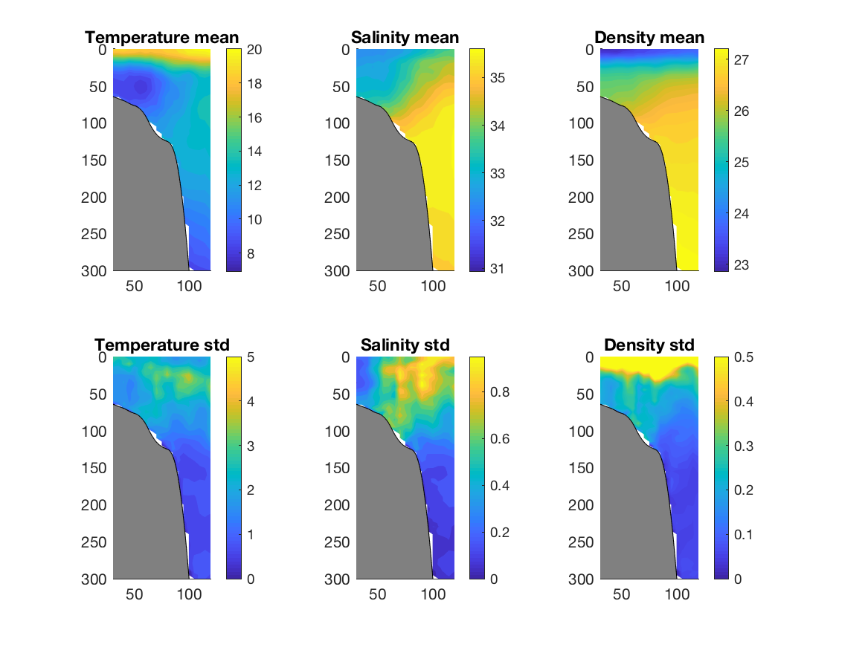

Fig 3: TS diagram for all stations. 2004 highlighted in red. 2013 in blue.

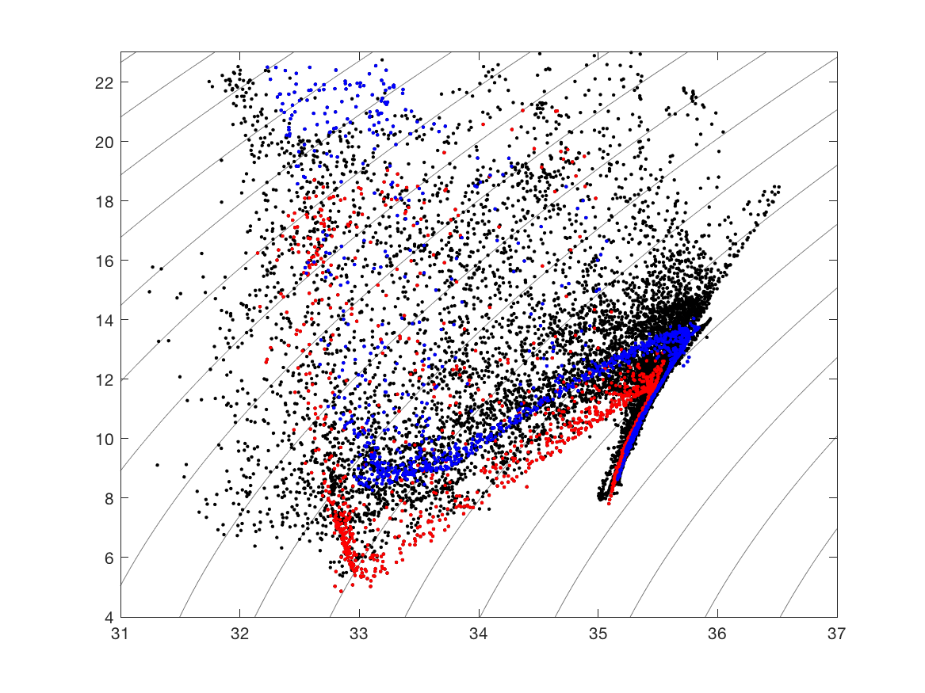

Fig 4: Example sections 2004 and 2013

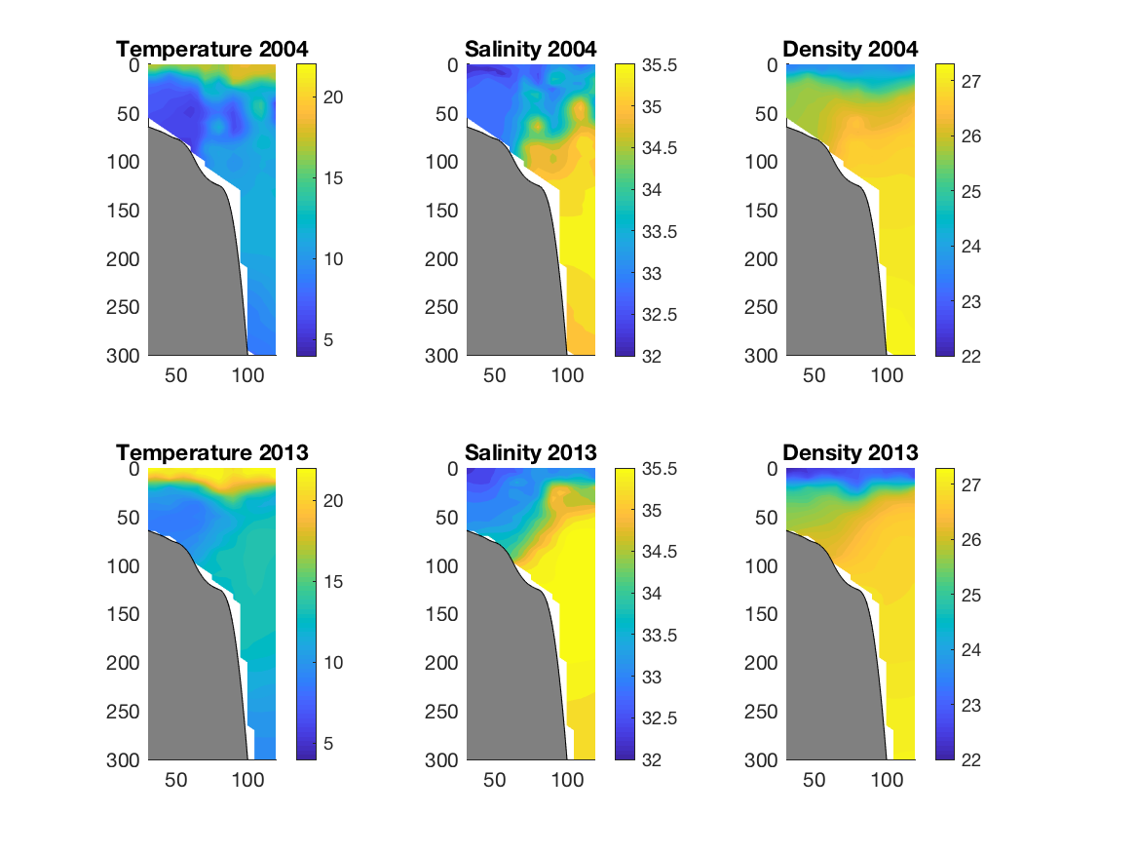

Fig 5: Property trend maps. Only colored trends that are significant at 95% confidence.

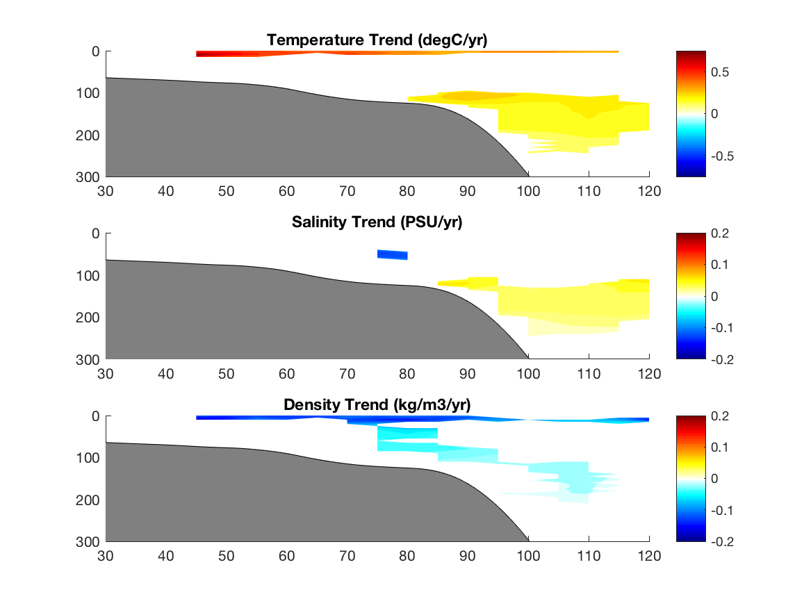

Fig 6: Cold pool trends from TS diagram

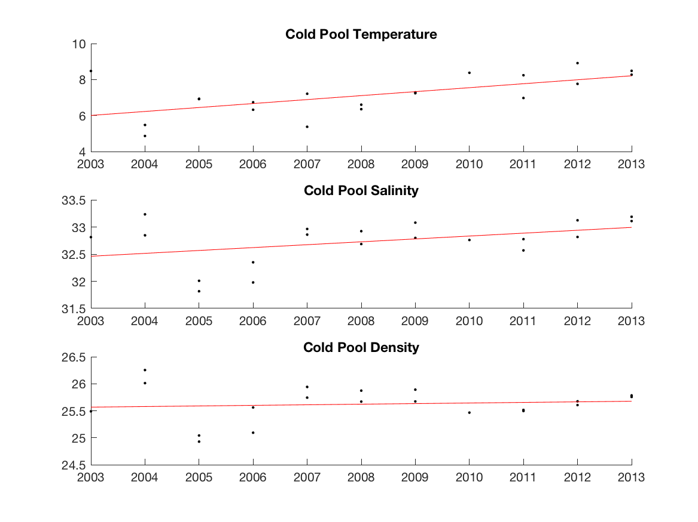

Fig 7: Shelf depth mean trends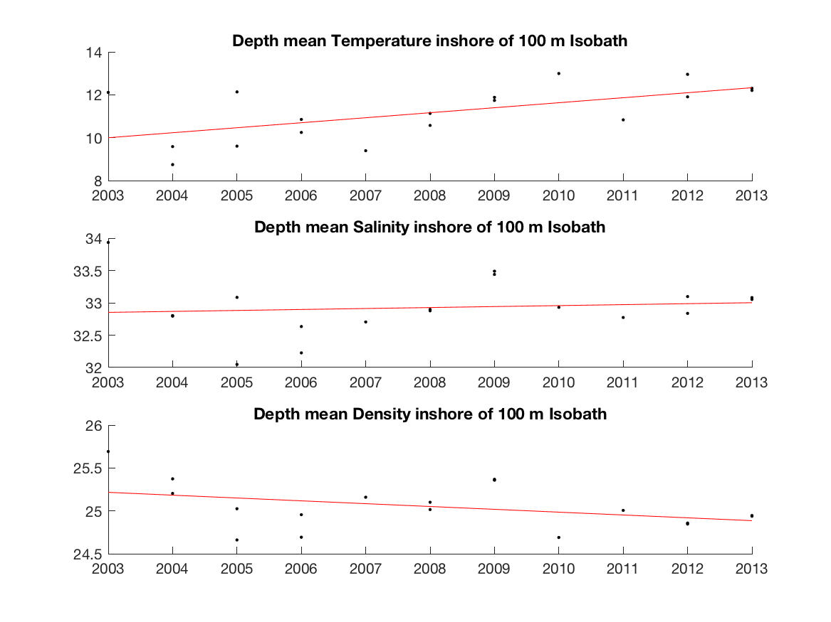

EXTRA FIG?: Trend in slope water (between 100 and 200m depth)

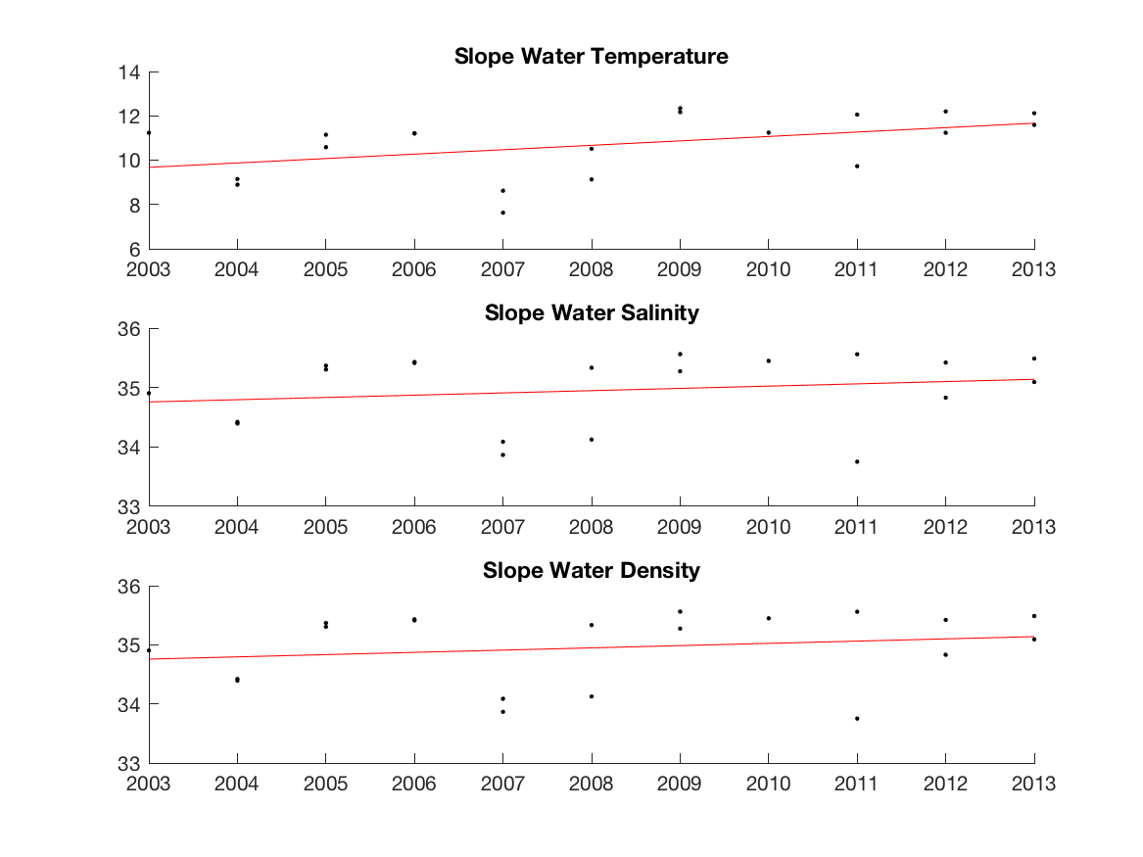

OR?: Slope and Cold Pool trends on the same figure? Probably make it thinner too.

­